PAYMENT
Send your booking voucher to :

Mme Nadine ECHIVARD
90 Rue du Serieyssols
81000 ALBI - FRANCE
portable : 06 62 42 50 82
Mail : nadechivard@gmail.com

Please do not send checks, but make a transfer (amount in Euro) to the order of (see RIB below) without forgetting to return your registration form

Banque Crédit Agricole

Bonsaï Club de l’Albigeois

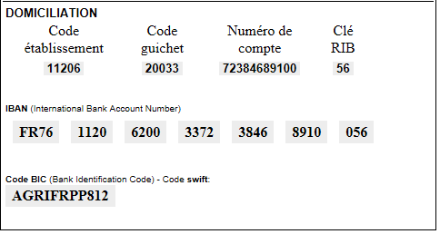

We will confirm your registration after your payment

Date: ..................................... Signature: ..........................................

After your registration, you will be informed by e-mail of your final reservation.

